

Practices for Secure Software Report

Table of Contents
Document Revision History 3
Client 3
Instructions 3
Developer 4
1. Algorithm Cipher 4
2. Certificate Generation 4
3. Deploy Cipher 4
4. Secure Communications 4
5. Secondary Testing 4
6. Functional Testing 4
7. Summary 4
8. Industry Standard Best Practices 4

Document Revision History

Version | Date | Author | Comments
1.0 | February 22, 2026 | Madeline Meyers

Client



Instructions

Submit this completed practices for secure software report. Replace the bracketed text with the relevant information. You must document your process for writing secure communications and refactoring code that complies with software security testing protocols.

- Respond to the steps outlined below and include your findings.
- Respond using your own words. You may also choose to include images or supporting materials. If you include them, make certain to insert them in all the relevant locations in the document.
- Refer to the Project Two Guidelines and Rubric for more detailed instructions about each section of the template.

Developer
Madeline Meyers

Algorithm Cipher

SHA-256 is the algorithm I will be recommending and implementing into this application for file verification. This cipher is mentioned in an article from Linux Security (Ulac, 2025) as a crucial step for file integrity verification of Linux distributions. This cipher creates a checksum hash which will always create the same hash for the same input and if any part of the input data has changed a different checksum hash will be generated by the cipher. This will immediately show if the file has changed during file transfer through the mechanism of creating a checksum that is different from the expected hash value.

The process of creating the hash value is done through taking the bits value of the data and shifting the bits through a unique process. This encrypts the data and then the encryption is sent through a processor function to convert the new bit value into a hexadecimal value to make it easier to read through while also obfuscating the original encrypted value. The hexadecimal value is what is referred to as the checksum hash and acts as the mechanism to verify the file integrity.

The reason I am recommending SHA-256 over a different bit level of SHA algorithm such as SHA-1 is due to the level of security provided. SHA-1 creates a 160 bit length output message compared to the 256 bit length output created by SHA-256. This greater length provides a greater level of security when verifying file integrity as it creates a longer message from the input data. This means that for any given input file there is an increased level of confidence that the hash value will be different. This is what allows SHA-256 to be considered “Collision Resistant” as an algorithm cipher as opposed to SHA-1 which is susceptible to collision attacks.

There are multiple types of algorithm ciphers such as those which use symmetric keys and asymmetric keys to secure communication between multiple points. These algorithms are very useful to secure the connection between computers and provide security when the computers are transferring information. However, it does not provide file verification when the file is received, it only provides a connection key that is verified between computers. All types of algorithms use random numbers when generating a set of keys or a hash value through an algorithmic process. This is used to create a securely encrypted data file that can either be sent through a reversible algorithm cipher or verified through running the same file through the same algorithm cipher.

As technology advances the need for greater levels of security increase. At one point SHA-1 was considered a great cipher for file verification but the algorithm was eventually cracked and able to be exploited. Afterwards, newer algorithms were developed that use different methods to create longer checksums that were more resistant to the method of cracking used against SHA-1. SHA-256 was created to be the next level of security and is the industry standard for file verification. This is why I have chosen this specific algorithm, and the specific bit level for this algorithm.

Certificate Generation
Insert a screenshot below of the CER file.

CER File Generated and placed within the project resources along with keystore
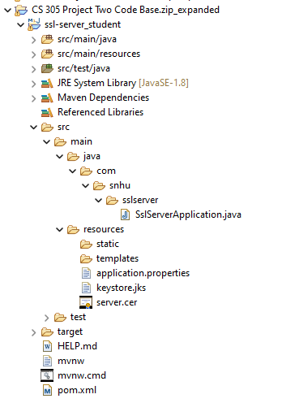

Printed output of CER file
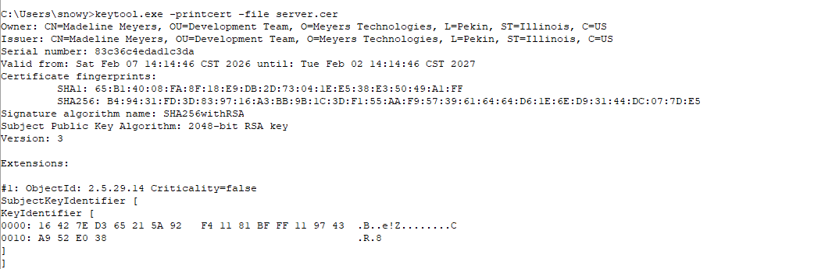

Deploy Cipher
Insert a screenshot below of the checksum verification.

Output of Project after implementing checksum verification

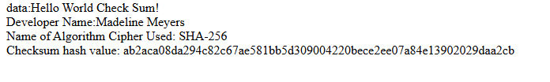
Checksum hash value is based on the data field. Developer name and algorithm name fields are decorative to verify the code was implemented by me and what algorithm cipher was used for the project.

Secure Communications
Insert a screenshot below of the web browser that shows a secure webpage.

Webpage for the checksum verification

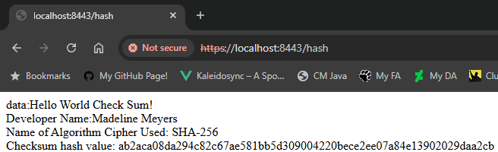

My primary internet browser is Chrome and although the connection claims to be not secure this is due to the certificate being self-signed rather than being issued through a trusted certificate authority.
Proof of Certificate Generated in Section Two
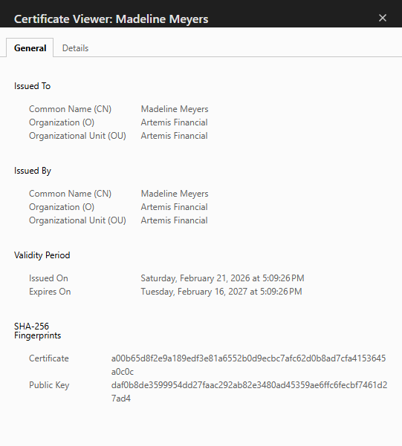

Secondary Testing
Insert screenshots below of the refactored code executed without errors and the dependency-check report.

Code Executed without Errors during Dependency Check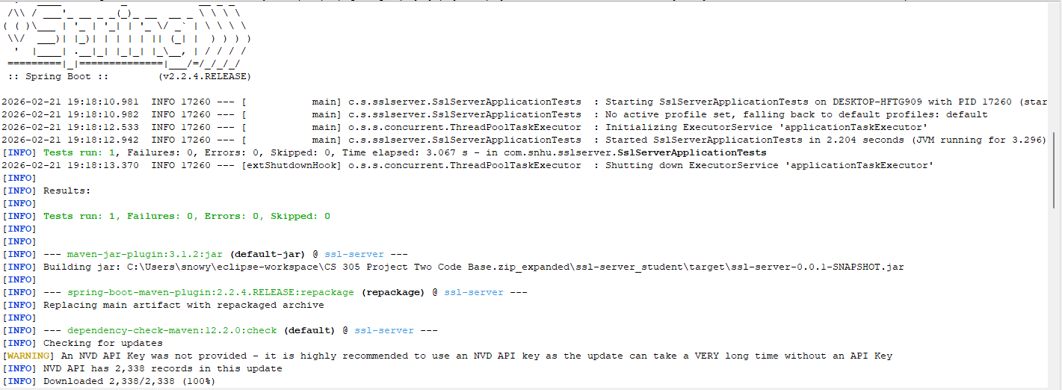

Required Refactoring to Access Keystore at Runtime

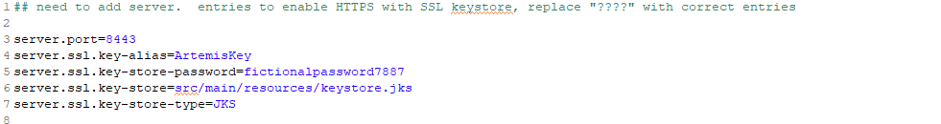

Screenshot of Dependency Check
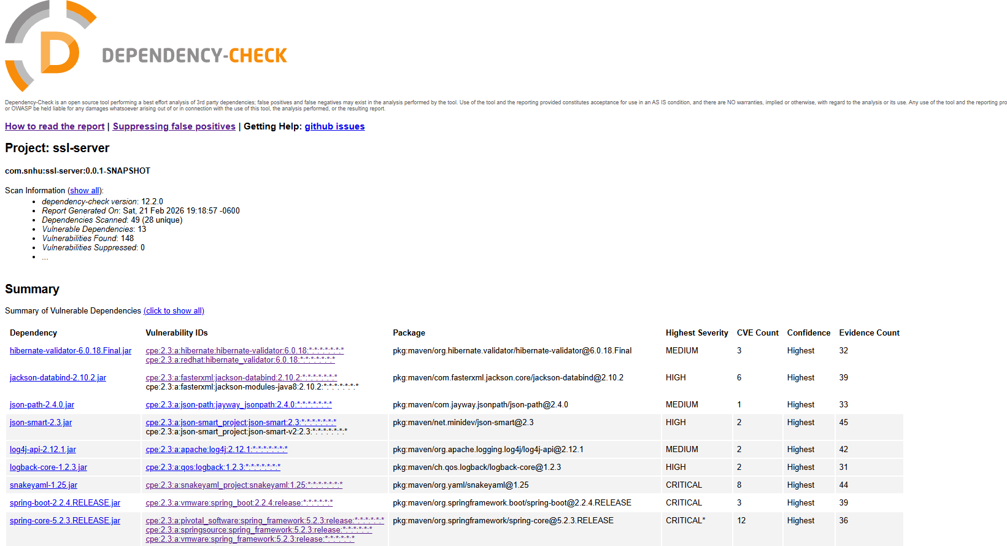

Functional Testing
Insert a screenshot below of the refactored code executed without errors.

Refactored Codebase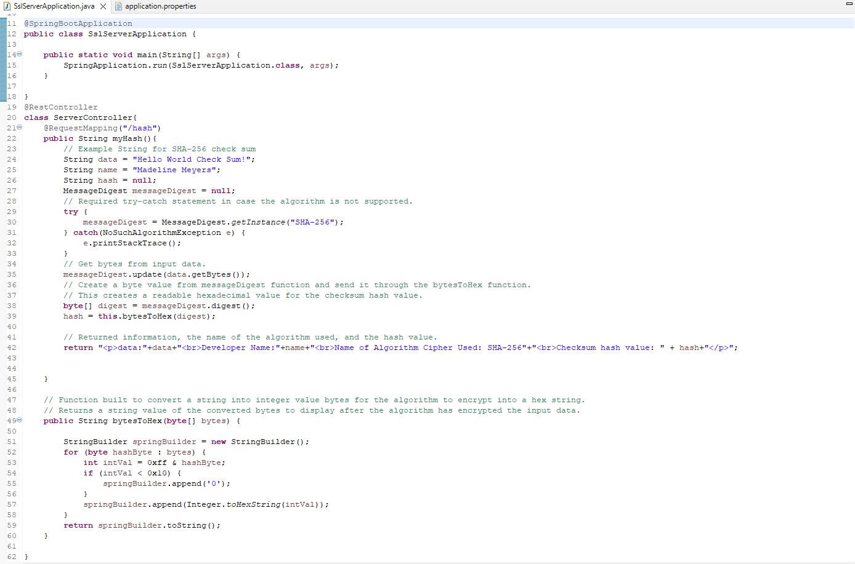

Proof Code Runs Without Errors

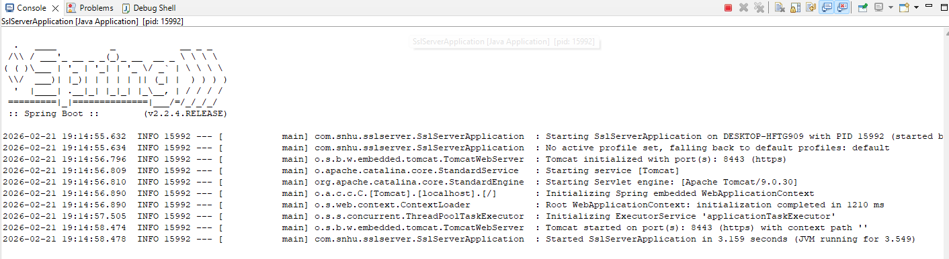

Summary

During this project I addressed the following areas of security.

First, input data was directly coded in this project and thus the input data could be more easily worked with and validated. This was done through a checksum verification step with a secure algorithm cipher. Next, the webpage associated with the checksum verification was implemented onto a secondary page through an API built for the program. This API was coded to only work with this data and not affect anything that will be built into other pages going forward. Next, after verifying the checksum was implemented correctly I also generated a self-signed certificate to enable https communication with the webpage. This enables a layer of security for those who would visit the webpage as the application is deployed in the future. I also examined the dependencies involved with the application to determine which will be handled during further development. The primary concern for the dependency check tool was that the dependencies are out of date and as such they should be updated after examining the use cases for these dependencies. Finally, proper error handling was implemented for the checksum verification stage to ensure that if it fails it will throw an error for developers to examine. The code quality for this project is at the highest level for Artemis Financial and the program functions as it should as per the business requirements.

Industry Standard Best Practices

Industry standard best practices informed my decision making at each level for the development of this program and implementation of the algorithm cipher. I verified that the cipher was well established and that it was secure to use for file transfer verification. I also verified that any additional code I implemented did not contribute to any new potential vulnerabilities to ensure that the security of the code was not compromised during development through the use of the OWASP dependency check tool. I also used a self-signed certificate for development purposes and ensured that the application properties are set to use the proper certificate without disrupting the application at runtime.

By ensuring the security of the application through the usage of industry standard best practices we are able to create programs that fulfil the business requirements for the program while also keeping the data that will be flowing through the application secure. Compromised data creates distrust for the application and the owners of the application and can lead to malicious actors gaining access to information that can cause harm. Secure coding practices provide a layer of protection for the data that makes it more difficult for attackers to gain access to the information.

References

Ulac, M. (2025, November 21). Linux integrity check: Sha256 and GPG verification guide. Linux Security. https://linuxsecurity.com/news/server-security/checksums-in-linux-integrity-guide

